**Function Used**

**json.load():**json.load() function is present in Python built-in ‘JSON’ module. This function is used to parse the JSON string.

**json.loads():**json.loads() function is present in Python built-in ‘json’ module. This function is used to parse the JSON string.

**Convert JSON String to Dictionary Python**

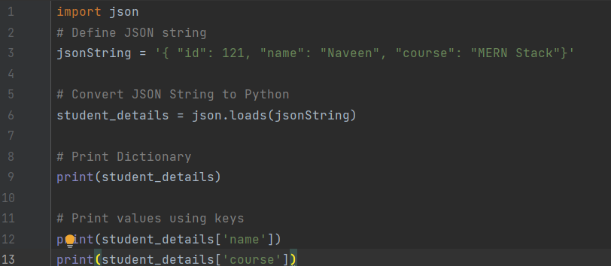

**Output:**

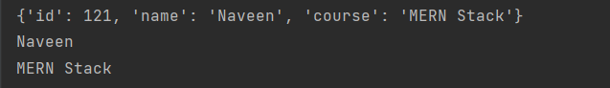

**Convert JSON File to Python Object**

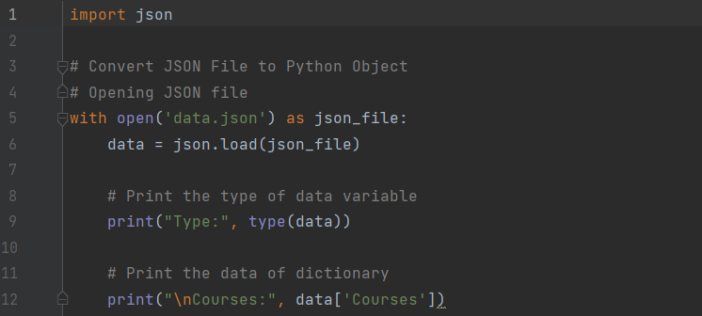

**Data.json file**

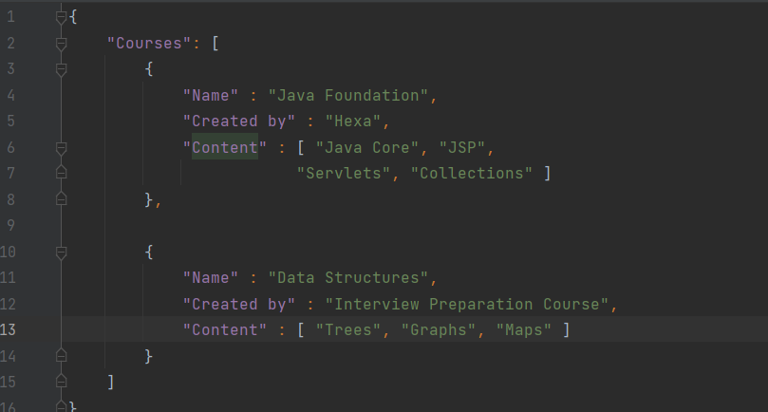

**Output:**



**Convert Nested JSON Object to Dictionary**

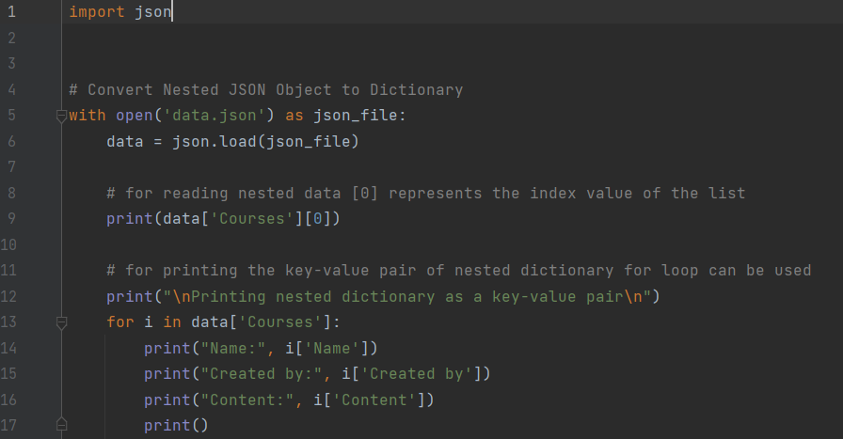

**Output:**

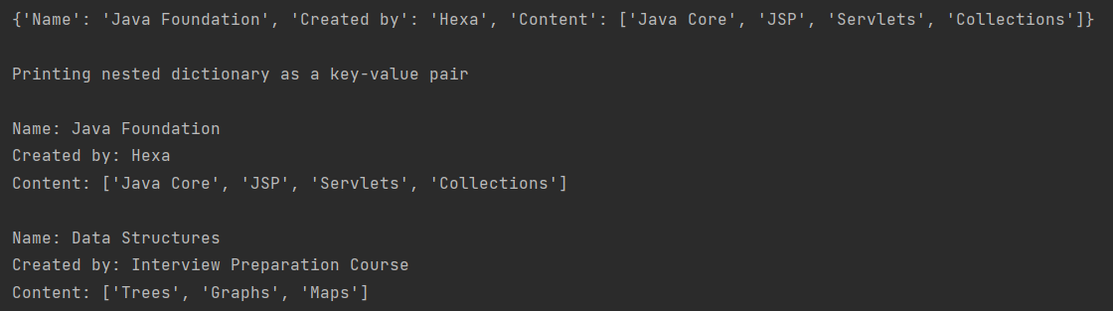

**Convert JSON String to Dictionary in Python**

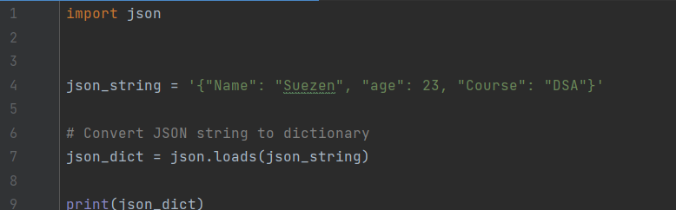

**Output:**



**Python Parse JSON String**

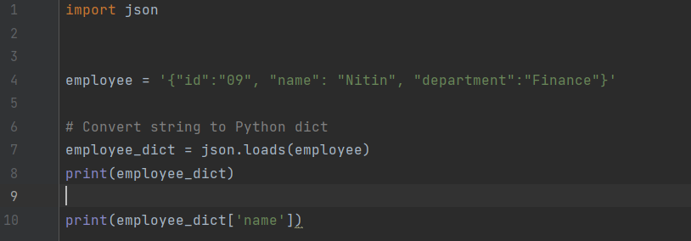

**Output:**



**Python read JSON file**

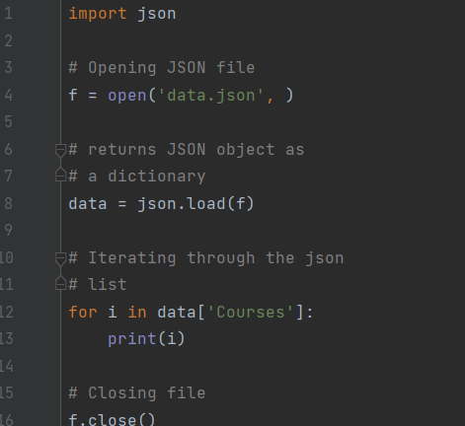

**Output:**



**Convert Python Dict to JSON**

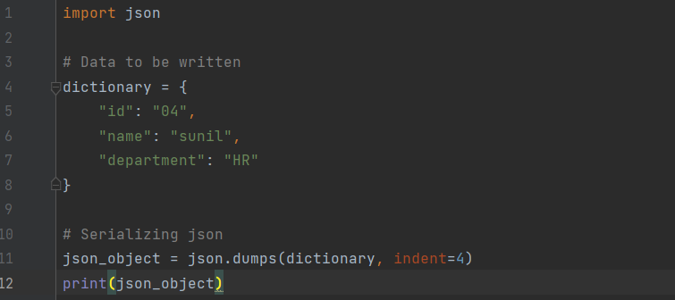

**Output:**

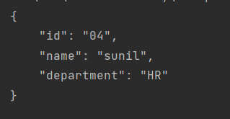

**Writing JSON to a file in Python**

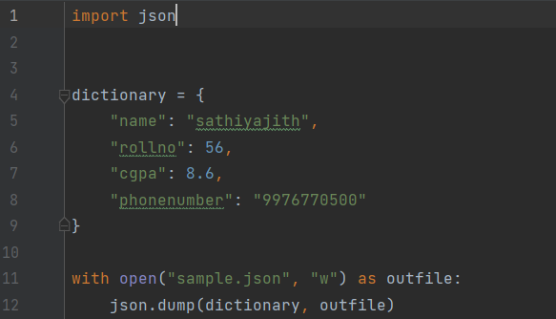

**Output:**

**Sample.json file**



**Python Pretty Print JSON**

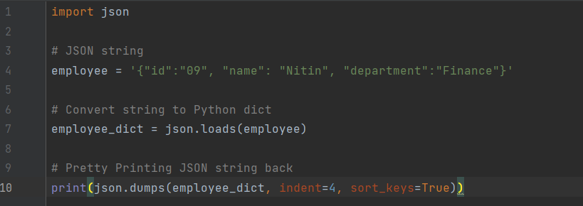

**Output:**

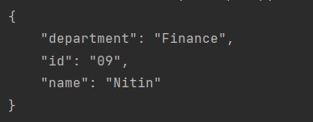

**Sorting in Desc order**

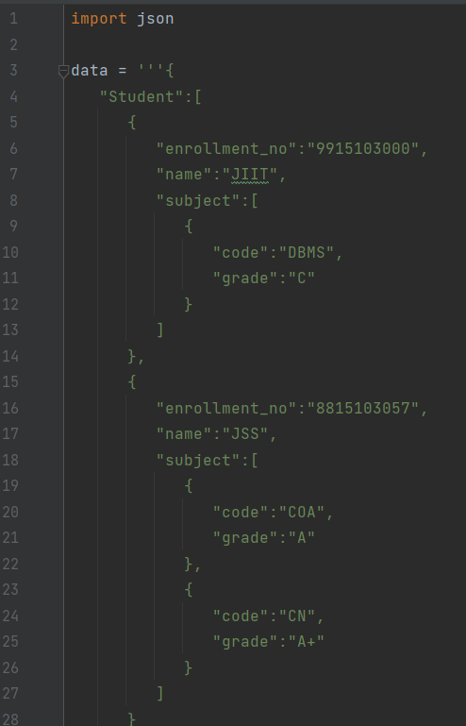

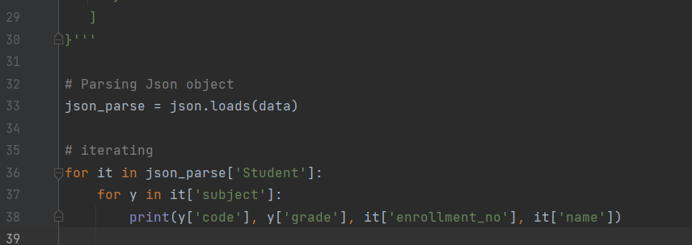

**Output:**

